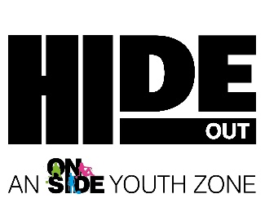
COMPLAINT FORM

The Complaints Form should be used in conjunction with HideOut Youth Zone’s Complaints Policy.

COMPLAINANT NAME:
CONTACT NUMBER:
EMAIL:
ADDRESS:

DATE OF COMPLAINT:
COMPLAINT MADE BY: | Email Letter Verbally to a HideOut Staff Member*
*STAFF MEMBER NAME:
COMPLAINT DETAILS:
COMPLAINANT SIGNATURE:
STAFF MEMBER SIGNATURE:
(if applicable)

Please complete the form in full and sign and email to adam.farricker@hideoutyouthzone.org or post/deliver to the address below. HideOut Youth Zone will acknowledge receipt of the complaint within 3 working days:

Adam Farricker
Chief Executive
HideOut Youth Zone
1 Queens Avenue
Gorton
M12 5PX

